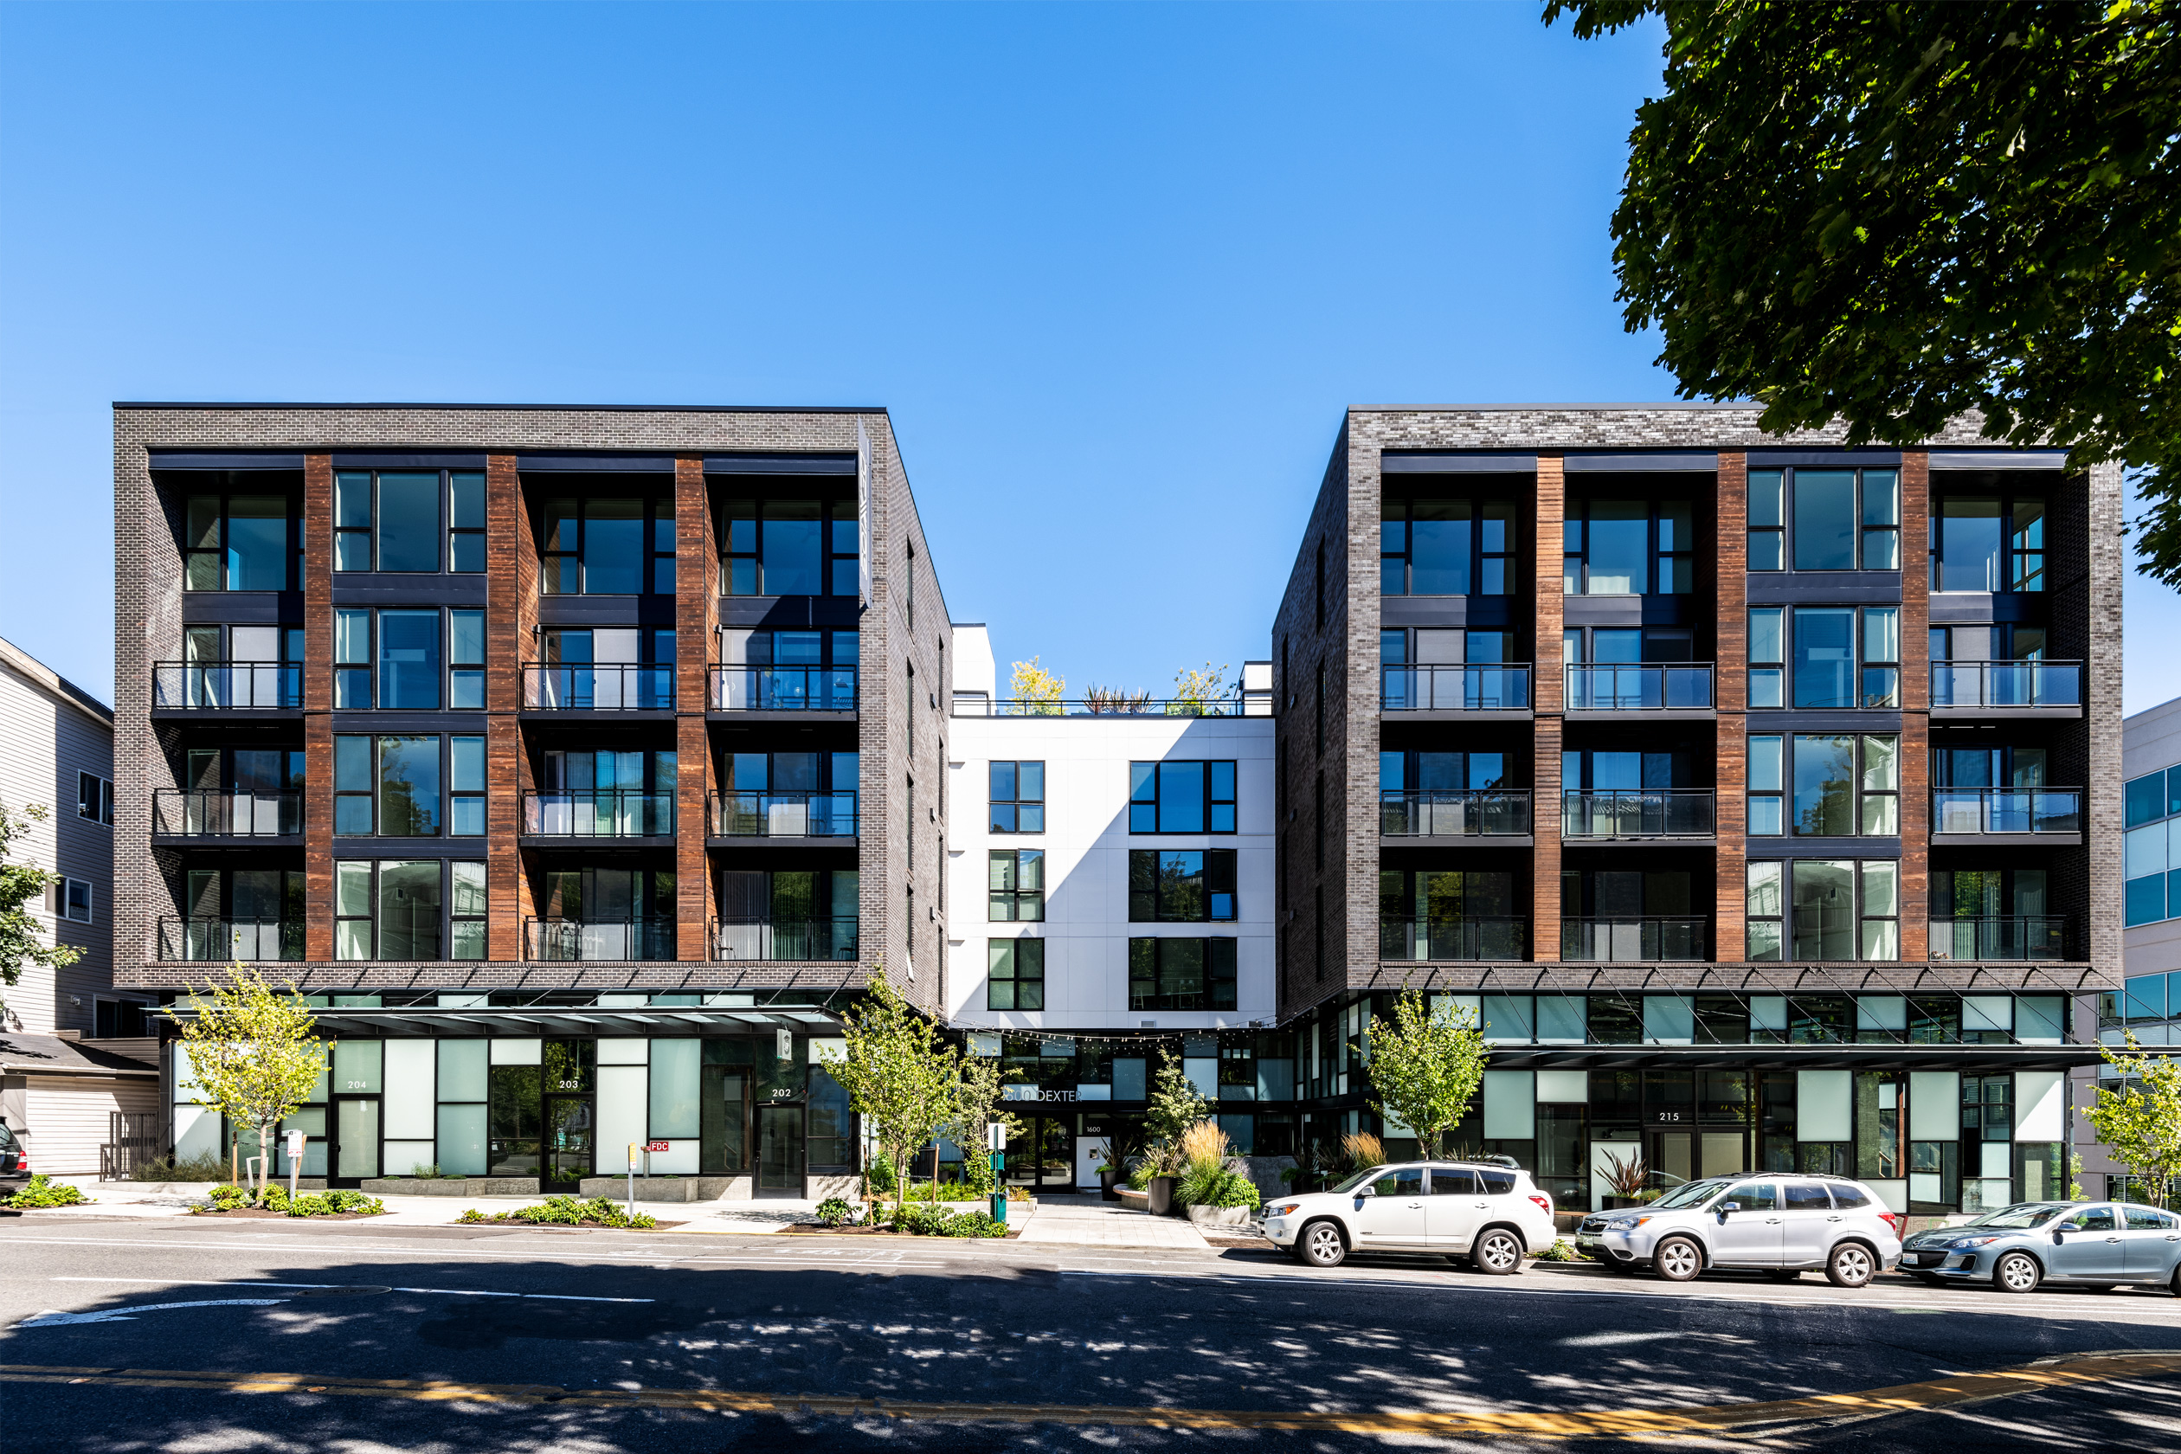

**MULTIFAMILY BRIDGE LOAN PROGRAM**

**LOAN ADVANCE**

• Up to {{mf_POC}}% of Purchase Cost (incl. closing costs)

• Up to {{mf_LTV}}% Loan to Value

**RATE AND TERMS**

• Interest Rates Starting at {{mf_int}}% (Interest Only Payments)

• Loan Fees – {{mf_loanfees}} (up front and/or at exit)

• Loan Amounts from {{mf_loanamt}}

• Loan Term - {{mf_loanterm}}

• Prepayment – Flexible Structure

**ADDITIONAL INFO**

• Multifamily Apartments

• First Lien Position, Select 2nd Liens or Preferred Equity

• Recourse and Non-Recourse with Standard Carve Outs

• Appraisal Waivers Available Below $15,000,000

• Target Closing Timeline - Less Than 30 days

Is a lack of deal flow or access to fast and flexible capital slowing you down? Foundation offers both innovative Bridge Loans and Off-Market Residential Properties so you can grow your real estate business.

+ Access to Off-Market Properties

**MULTIFAMILY BRIDGE**

**LOAN PROGRAM**

**THE FOUNDATION FORMULA**

**Properties + Capital + Speed = Profits**

**{{first_name}} {{last_name}} • {{phone}} • {{email}} • foundationcref.com**

**Contact {{first_name}} {{last_name}} Today for a Free Loan Quote**

**- or - to *Get Access to Off-Market Properties***