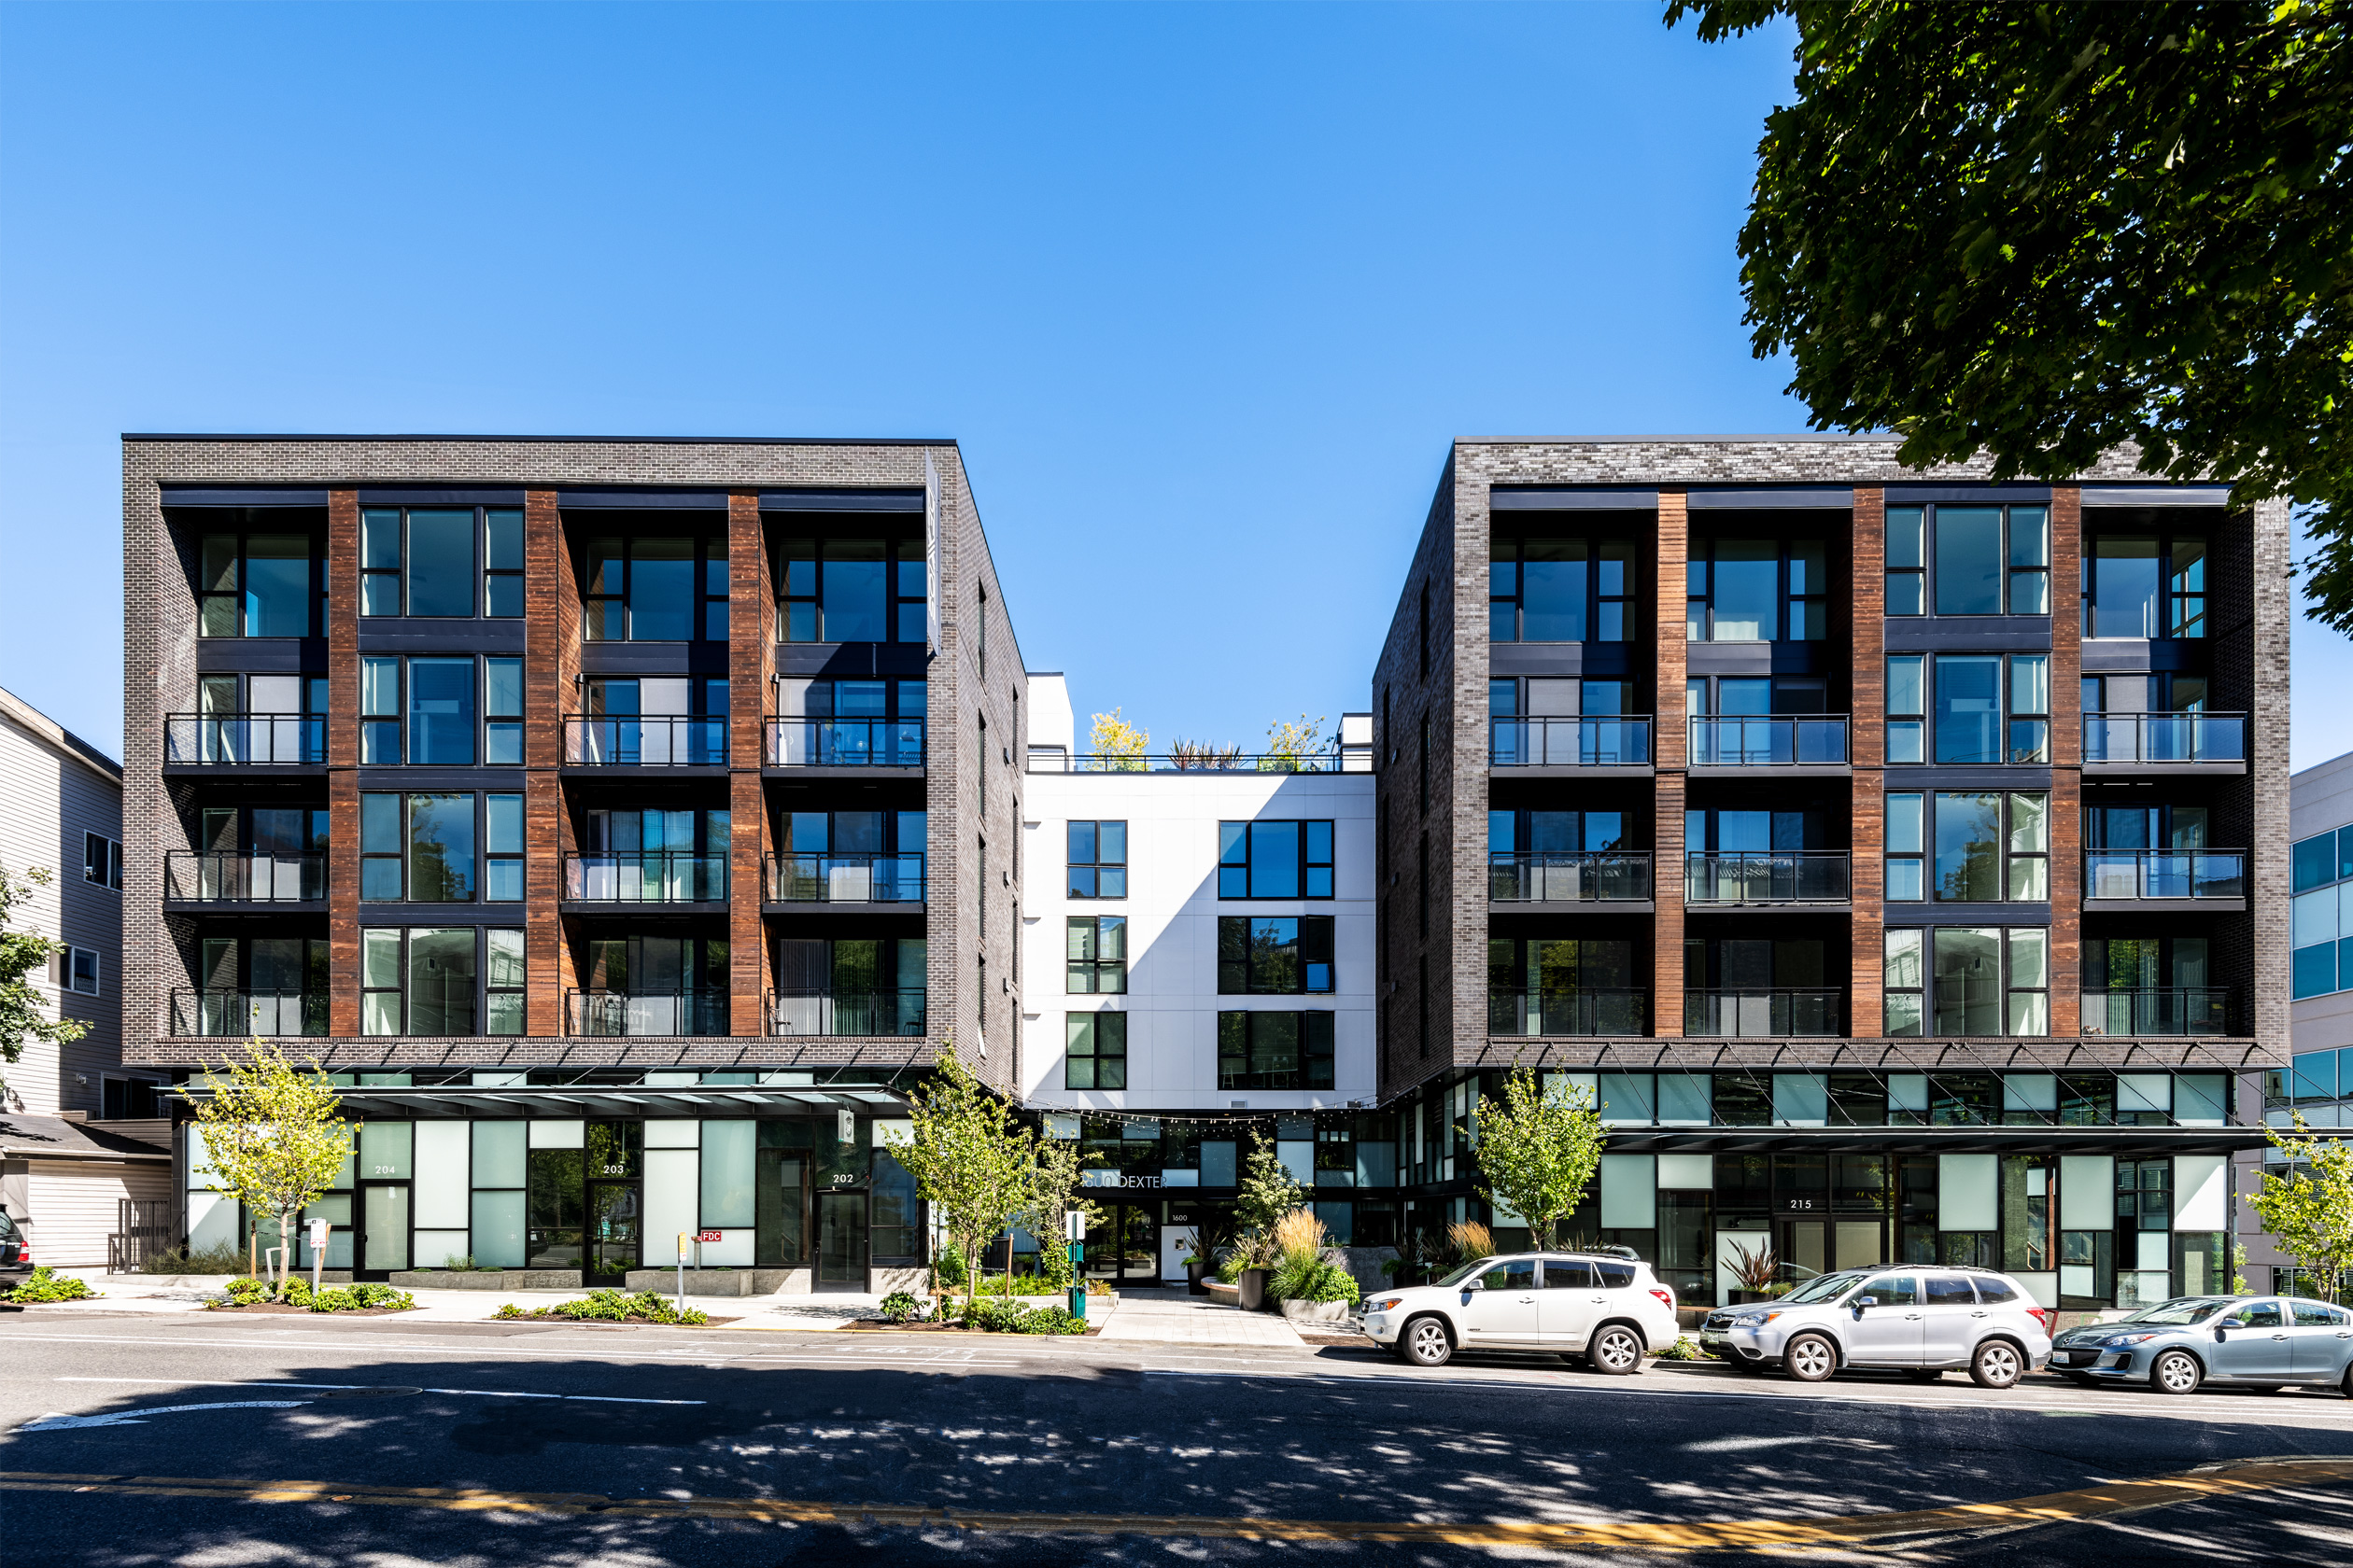

**MULTIFAMILY BRIDGE LOAN PROGRAM**

**LOAN ADVANCE**

• Up to 75% of Purchase Cost (incl. closing costs)

• Up to 75% Loan to Value

**RATE AND TERMS**

• Interest Rates Starting at 8.99% (Interest Only Payments)

• Loan Fees – 1.0% to 3.0% (up front and/or at exit)

• Loan Amounts from $500,000 to $30,000,000

• Loan Term - 12 to 36 Months

• Prepayment – Flexible Structure

**ADDITIONAL INFO**

• Multifamily Apartments

• First Lien Position, Select 2nd Liens or Preferred Equity

• Recourse and Non-Recourse with Standard Carve Outs

• Appraisal Waivers Available Below $15,000,000

• Target Closing Timeline - Less Than 30 days

Is a lack of deal flow or access to fast and flexible capital slowing you down? Foundation offers both innovative Bridge Loans and Off-Market Residential Properties so you can grow your real estate business.

+ Access to Off-Market Properties

**MULTIFAMILY BRIDGE**

**LOAN PROGRAM**

**THE FOUNDATION FORMULA**

**Properties + Capital + Speed = Profits**

**{{first_name}} {{last_name}} • {{phone}} • {{email}} • foundationcref.com**

**Contact {{first_name}} {{last_name}} Today for a Free Loan Quote**

**- or - to *Get Access to Off-Market Properties***