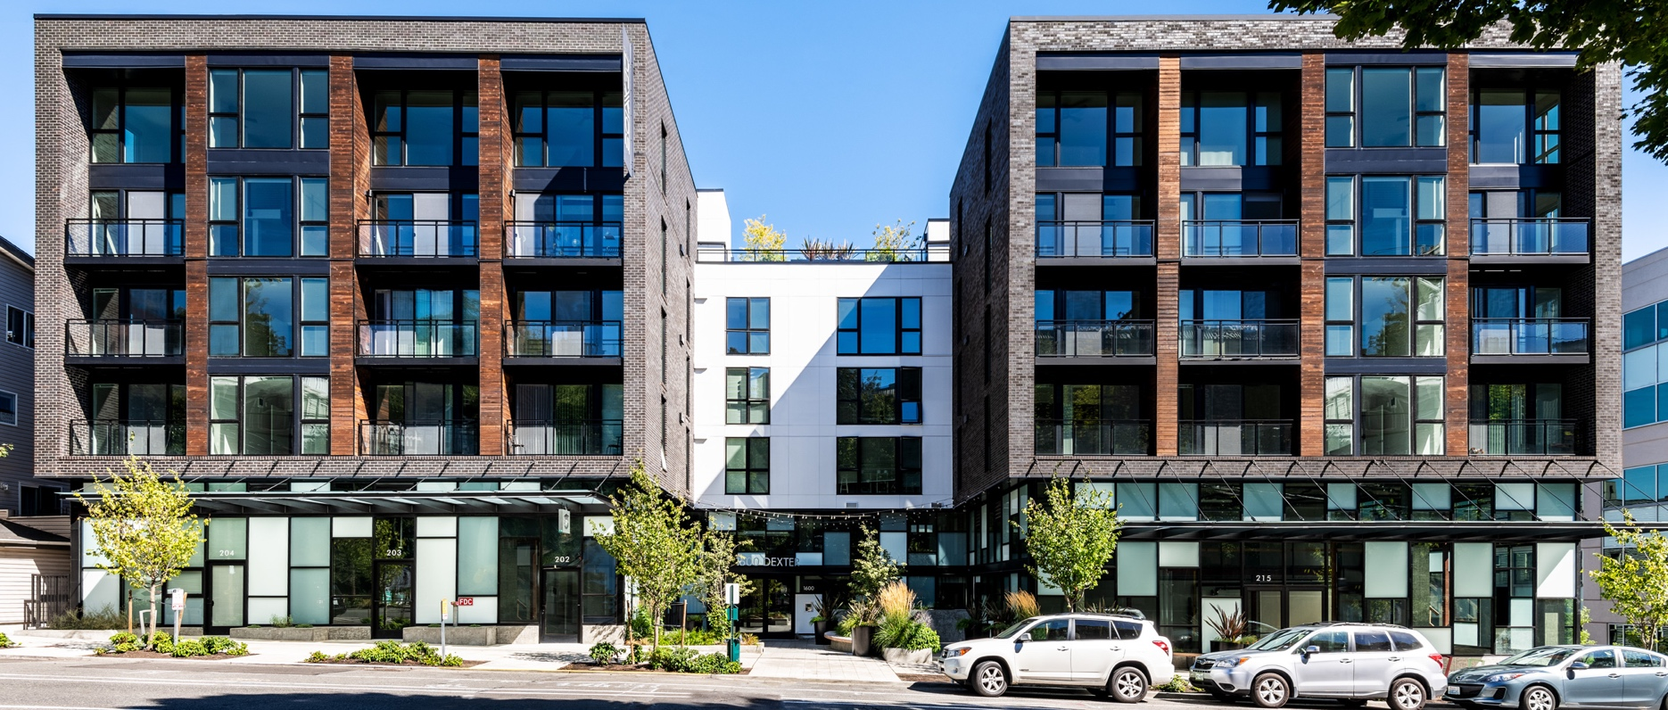

**ADDITIONAL INFO**

• Multifamily Apartments

• First Lien Position, Select 2nd Liens or Preferred Equity

• Recourse and Non-Recourse with Standard Carve Outs

• Appraisal Waivers Available Below $15,000,000

• Target Closing Timeline - Less Than 30 days

**LOAN ADVANCE**

• Up to 75% of Purchase Cost (incl. closing costs)

• Up to 75% Loan to Value

**RATE AND TERMS**

• Interest Rates Starting at 8% (Interest Only Payments)

• Loan Fees – 1.0% to 3.0% (up front and/or at exit)

• Loan Amounts from $500,000 to $30,000,000

• Loan Term - 12 to 36 Months

• Prepayment – Flexible Structure

**MULTIFAMILY BRIDGE LOAN PROGRAM**

**Up to 75% Loan to Value**

{{phone}} | {{email}}

{{first_name}} {{last_name}} | {{entity_name}}

Is a lack of deal flow or access to fast and flexible capital slowing you down? We offer both

innovative Bridge Loans and Off-Market Properties so you can grow your real estate business.

**MULTIFAMILY BRIDGE LOANS**